

CONTENTS

Getting Started with Appium and Finding Mobile Elements

|  |  |  |  |  |  |  |
| --- | --- | --- | --- | --- | --- | --- |
| # | Author | Changes Made | Date | Version | Reviewer | Approver |
| 1 | LamNS3 | docs: create template file | 18/01/2019 | 1.0.0 |  |  |

Table of Contents

Exercise 01 3

Exercise 02 4

Exercise 03 5

Exercise 04 7

# Exercise 01

Create Automation Script to verify Sign in function.

Step 1: Install Startbucks app

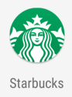

Step 2: Open Startbucks app and tap Sign In item

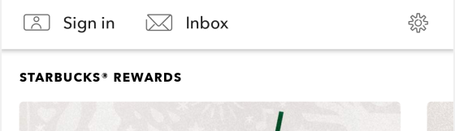

Step 3: Verify Email textbox, Password textbox and Sign in button should be displayed.

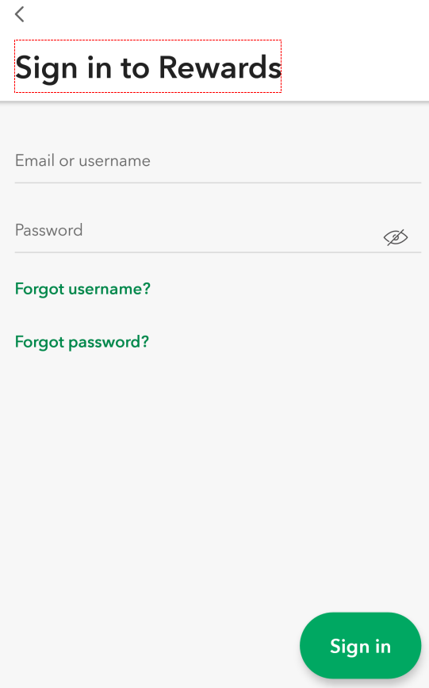

Step 4: Input Email, Password and get Error Message with conditions as bellows:

1. Case 1:

Email: input blank value

Password: input “abcd”

1. Case 2:

Email: input “abcd”

Password: input blank value

# Exercise 02

Create Automation Script to verify Setting function.

Step 1: Install Startbucks app



Step 2: Open Startbucks app and tap setting icon

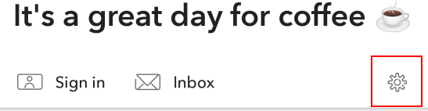

Step 3: In Settig screen, click Application Terms

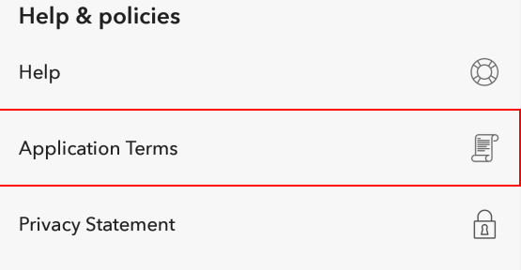

Step 4: Verify text should be contains string “**PLEASE READ THESE TERMS OF USE CAREFULLY**”

# Exercise 03

Create Automation Script to verify Sign in function.

Step 1: Install Amazon Shopping app

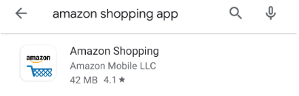

Step 2: Open Amazon Shopping app and tap Skip Sign In button

Step 3: Search “Samsung galaxy s10 plus case”

Step 4: Click first product

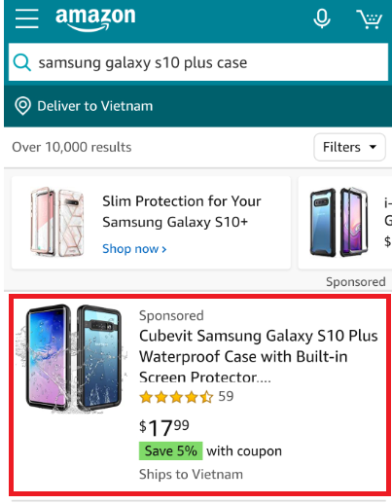

Step 5: Verify product name, product description and price must be displayed.

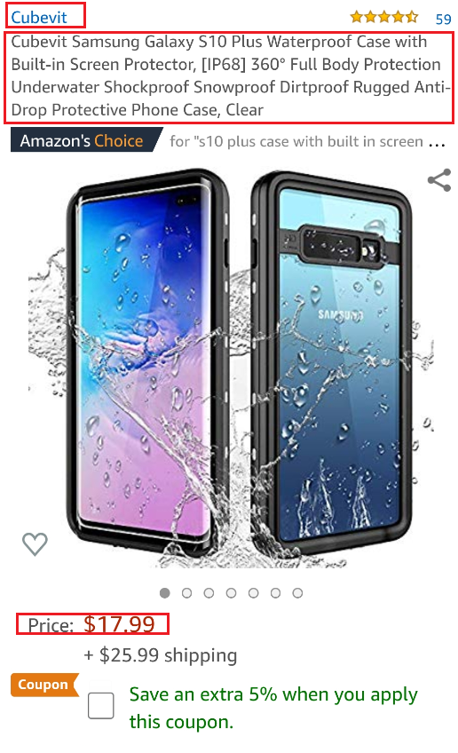

# Exercise 04

Create Automation Script to verify Sign in function.

Step 1: Install Amazon Shopping app

Step 2: Open Amazon Shopping app

Step 3: Click to the menu on top

Step 4: Click to the “Sign In”

Step 5: Click to the “Create Account”

Step 6: Input Name, Email and Password.

Step 7: Click to the “Verify email” button.

Step 8: Verify OTP screen must be display: Enter OTP textbox, Create your Amazon account button.

